SLCH _ WUSTL QI Project Submission Form
Project Title: |  | Date Submitted:
QI Checklist
 |  | Response
Purpose: | Is the project primarily intended to improve patient care processes, outcomes, or system performance at SLCH? | *If yes, likely QI Yes  No
Scope/Evidence: | Does the project aim to evaluate or improve current practice based upon existing knowledge and evidence that is generally accepted by SLCH clinicians or leadership? | *If yes, likely QI Yes  No
Risk: | Is the risk or burden to participants greater than what normally exists in the care they are already receiving? | *If yes, likely research  Yes No N/A
Methods/Design: | Are the methods for the activity adaptive, iterative, and include approaches to evaluate rapid and incremental changes? | *If yes, likely QI Yes  No
Consent: | Will the consent for treatment that is already obtained in clinical practice cover the planned activity? | *If yes, likely QI Yes  No N/A
Benefits | Is the intent of this project to benefit current patients at SLCH? | *If yes, likely QI Yes  No
Participant Obligation | Will participants be obligated to participate as a standard component of care? | *If yes, likely QI Yes  No

Project Overview

Project Lead:
SLCH employee or WUSM physician
Title:
Department:
Email:
Phone:
Is the Project Lead a Nurse-Resident-Faculty-Fellow?

Co-Project Lead:
SLCH employee or WUSM physician
Title:
Department:
Phone:
Email:
Is the Co-Project Lead a Nurse-Resident-Faculty-Fellow?

Sponsor:
SLCH employee or WUSM physician
Title:
Department:
Phone:
Email:
Is the Sponsor a Nurse-Resident-Faculty-Fellow?

Co-Sponsor:
SLCH employee or WUSM physician
Email:
Is the Sponsor a Nurse-Resident-Faculty-Fellow?

Referred by IRB? Yes No NA

Facility(s) where project will be implemented:
QI Topic:

Does this fulfill an academic requirement? Yes No
*If yes, what University/College/Institution?
What Degree /Graduate Training?

Anticipated Project Start Date:
Anticipated Project End Date:

Will faculty be able to receive MOC credit for participating in this project? Yes No

If yes, please review Appendix A (PEDIATRICIAN CRITERIA FOR MEANINGFUL PARTICIPATION) and provide project criteria for MOC. This should include clear plan for a cadence of communication of results to the faculty applying for MOC. Sharing process and outcome will help inform next PDSA

Project Summary
Briefly summarize the background of the problem and provide a brief description of the project.

What are you trying to change? State the best practice that is generally accepted by SLCH clinicians or leadership.

What is your improvement goal? Please include a SMART Aim (with baseline data). (An aim statement should state a clear, quantified goal set within a specific time frame. It states what you plan to change, by how much, and by when).

Describe the sample and setting in which the project will be conducted. Define the population. Include any relevant patients or settings that will be excluded and rationale for exclusion.

Describe the drivers that your intervention(s) will target (please include key driver diagram).
If possible, include an example of your PDSA that could be included with each driver in your iterative plan for improvement.

Identify process, outcome, and balancing measures that will be used to evaluate the effectiveness of the intervention and how consistently it is implemented. Include unit of measure and the numerator and denominator (if applicable). Please include your sampling plan and how you will share iterative measures at a regular cadence with your team.

Specify data collection methods – what data will be collected, how, by whom and how frequently:

Describe methods for data display and analysis:

Describe the methods for distribution of the data results to the entire team and any additional key stakeholders:

List Relevant Pediatric Subspecialties: ☐Adolescent Medicine; ☐General Peds;
☐Medical Toxicology; ☐Peds Cardiology; ☐Peds Endocrinology; ☐Peds ID; ☐Peds Pulm
☐Sleep Med; ☐Child Abuse Peds; ☐Hospice & Palliative Med; ☐Neonatal-Perinatal Med
☐Peds Critical Care; ☐Peds GI; ☐Peds Nephrology; ☐Peds Rheum; ☐Sports Med;
☐Developmental-Behavioral Peds; ☐Hospital Med; ☐Neurodevelopmental Disabilities;
☐Peds Emergency Med; ☐Peds Hematology-Oncology; ☐Peds Neurology;
☐Peds Transplant Hepatology

Keywords: Please list 3-4 key search terms/phrases (e.g. falls, hand hygiene, noise)

Project Methodology
Follow-up Action Plan
In quality improvement, there should be a commitment to implementing a plan for follow-up based on the outcomes of the project. How will the results be used to improve care, processes, or outcomes at SLCH?

PEDIATRICIAN CRITERIA FOR MEANINGFUL PARTICIPATION:
Physician Meaningful Participation is defined by the ABP as involving both an active role in the project, and participation over an appropriate time period. The ABP approves QI projects in which pediatricians are active participants in implementing change.
- Active Role: for MOC purposed, means the pediatrician must:
  - Be intellectually engaged in planning and executing the project
  - Participate in implementing the project’s interventions (the changes designed to improve care).
  - Review data in keeping with the project’s measurement plan
  - Collaborate actively by attending team meetings, whether in person or virtually.
- Length of Participation: The ABP looks to the QI project leadership to set the requirements for length of participation (minimum duration of participation) based on the nature and needs of the project. Most MOC approved projects to date have required 6-12 months of participation.
- MOC Activity Completion: When a pediatric has fulfilled the requirements of the meaningful participation, the pediatrician has “completed” the activity for purposed of MOC credit (MOC activity completion). Note that the pediatrician’s MOC activity date must be within the cycle of the pediatrician’s current certificate or MOC cycle.
Please use the space below to outline the physician’s meaningful participation for the project:

FUNDING:

Will this project be supported by funding or any in-kind donations, such as equipment loan?: Yes No

*If yes, funding type? (internal or external): Funding source or agency name:

Conflict of Interest

Are there any potentially relevant financial and non-financial conflicts of interest of individuals?
Yes No

*If yes, please list the potential conflicts of interest.

If you have any documents you wish to attach to your project for the review process, please email these documents, including your key driver diagram to Joan Smith (joanrs@bjc.org), Jaclyn Veile (jveile@wustl.edu), Dan Willis (dwillis22@wustl.edu), or Beverly Brozanski (Beverly.brozanski@wustl.edu).

When sending, please provide the sponsor name and project title within the email. Thanks!

Appendix A: ABP Requirements for MOC
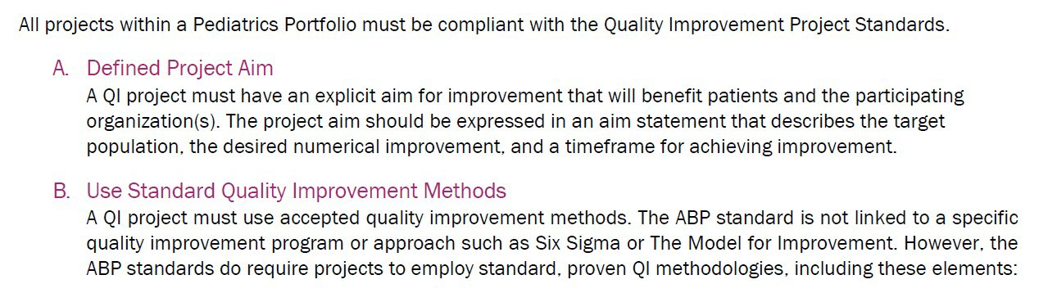
e
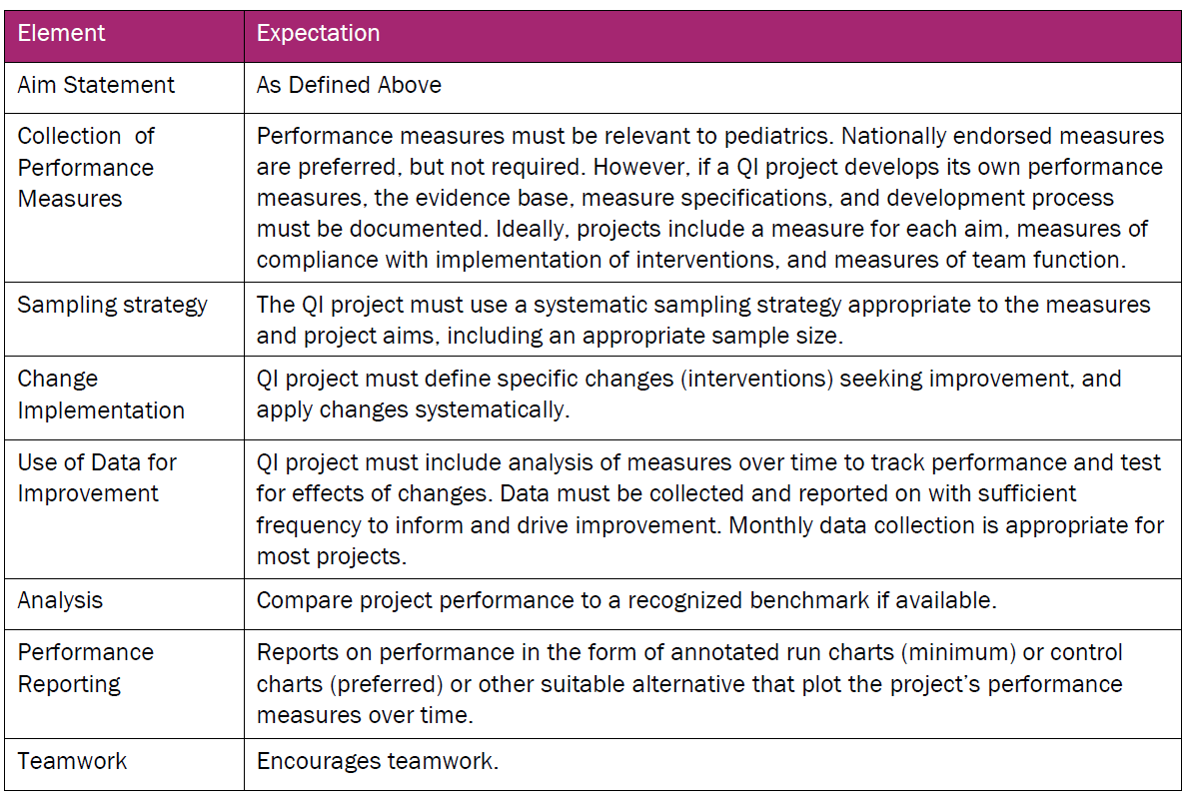
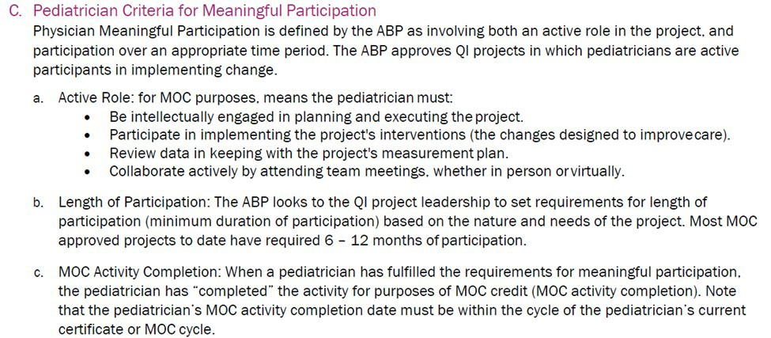

Pediatric Physician Sponsor should send attestations with faculty name and ABP number to Jaclyn Veile at jveile@wustl.edu

