SLCH / WUSTL Quality Improvement Project Submission Form
Date Submitted:
1. Project Identification
Project Title

Facility(s) where project will be implemented

QI Topic / Focus Area

2. Project Team & Oversight
Project Lead:
Title:
Department:
Email:
Phone:
Role:

Co-Project Lead:

Title:
Department:
Phone:
Email:
Role:

Sponsor:

Title:
Department:
Phone:
Email:
Sponsor Role:

Co-Sponsor (if applicable)

Email:
Sponsor Role:

Project Team Members
Name | Role | Department | PHI Access (Y/N)

3. Divisional Stakeholder Alignment
Division(s) impacted and Divisional Leaders

Divisional Leadership Acknowledgment Required Yes No
Letter of Support obtained Yes Pending
Alignment with division or department priorities

4. QI vs Research Determination
 |  | Response
Purpose | Is the project primarily intended to improve patient care processes, outcomes, or system performance at SLCH? | Yes No
Scope/Evidence | Does the project aim to evaluate or improve current practice based upon existing knowledge and evidence that is generally accepted by SLCH clinicians or leadership? | Yes No
Risk | Is the risk or burden to participants greater than what normally exists in the care they are already receiving? | Yes No
Methods/Design | Are the methods for the activity adaptive, iterative, and include approaches to evaluate rapid and incremental changes? | Yes No
Consent | Will the consent for treatment that is already obtained in clinical practice cover the planned activity? | Yes No
Benefits | Is the intent of this project to benefit current patients at SLCH? | Yes No
Participant Obligation | Will participants be obligated to participate as a standard component of care? | Yes No

Referred by IRB
Yes No N/A

5. Project Overview
Background & Problem: Briefly summarize the background of the problem and provide a brief description of the project.
Best Practice Target: describe what are you trying to change

SMART Aim Statement with baseline data
An aim statement should state a clear, quantified goal set within a specific time frame. It states what you plan to change, by how much, and by when.

6. Population & Setting
Target Population (include information for regarding the population impacted).

Setting (include any relevant patients or settings, including rationale for exclusion)

7. Intervention Design
Describe Key Drivers & Interventions: Please attach a Key Driver Diagram.
Envision Plan Do Study Act (PDSA) Cycles that could be included with each driver.

8. Measures & Evaluation
Definitions
Outcome Measure: The main result the project is trying to improve. It reflects the impact on patients, systems, or key goals.
Process Measure: A measure of whether the specific steps or interventions in the project are being carried out as intended. It reflects what the team is doing to achieve the outcome.
Balancing Measure: A measure used to assess for unintended consequences elsewhere in the system because of the intervention. It ensures that improvements in one area are not causing harm in another (e.g., increased workload, delays, new safety issues).
(Include numerators and denominators for all measures)
Outcome Measure:

Process Measure(s):

Balancing Measure(s):

9. Data Collection & Analysis
Data Collection (comment on what/how/by whom/frequency)
Proposed Data to be collected:

Data Extraction Plan:

Data collection frequency:
Analysis & Display: Describe your plan for data analysis and display.
Run Charts: Plot data points in time order (e.g., weekly/monthly). Include a median line to identify shifts or trends. Annotate charts with interventions (PDSA cycles)
Control Charts (SPC Charts): Used when sufficient data points are available. Include a centerline (mean) and upper/lower control limits to distinguish true improvement from random variation. Apply standard rules for special cause variation.

10. Data Security & Privacy
PHI used Yes No
Data Storage

Data Access

Data Protection Measures

Data shared outside team Yes No
Data Sharing Plan & Details

Data de-identified Yes No
De-identification Plan

Complies with HIPAA & institutional policy

11. Dissemination Plan
How results will be shared to help facilitate spread? Examples include local/institutional spread, educational integration, and external dissemination.

12. Follow-Up & Sustainability Plan
Sustainability strategy: summarize your plan for maintaining improvement after initial implementation, including but not limited to monitoring, feedback, training, and changes in workflows (protocols, etc.)

13. Funding
Funding used Yes No
Source / Type

14. Conflict of Interest (financial or non-financial)
Yes No

Details (if yes)

15. Keywords
List 3-4 key search terms/phrases (e.g. falls, hand hygiene, noise)

16. Attachments
Submit supporting documents separately to Emily Wambold (emily.wambold@bjc.org), Jaclyn Veile (jveile@wustl.edu), or Beverly Brozanski (Beverly.brozanski@wustl.edu).

When sending, please provide the sponsor name and project title within the email.

Examples include: letter of support, key driver diagram, PDSA cycle

ABP MOC Participation for Physicians
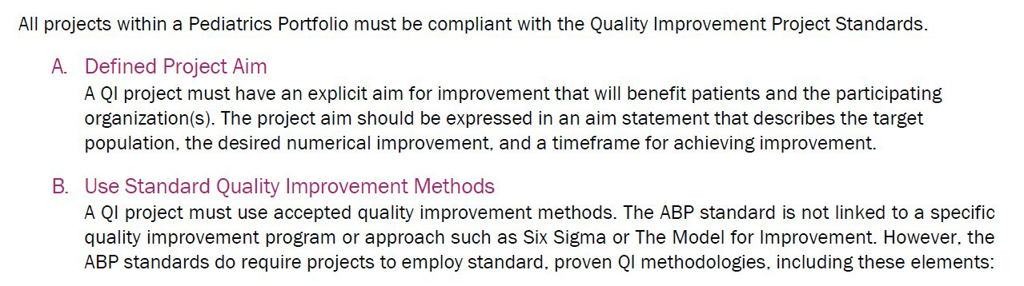
Complete the following if you would like to apply for ABP MOC Part 4 Credit.
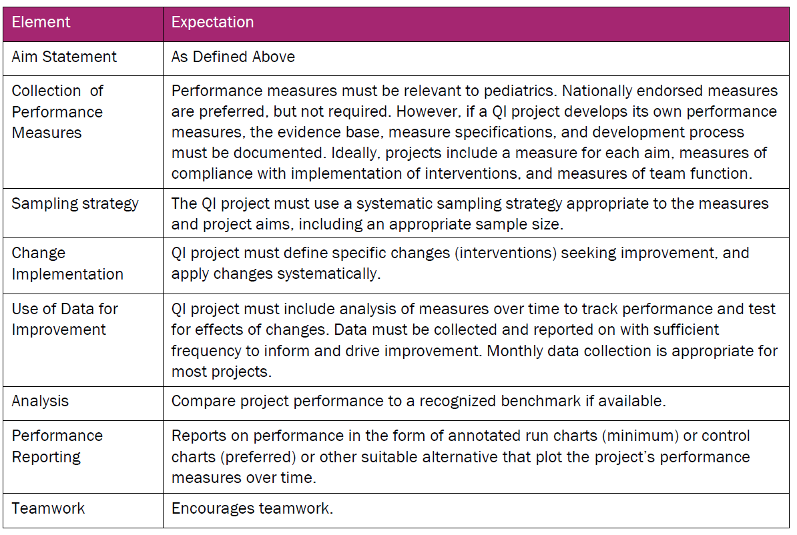

PEDIATRICIAN CRITERIA FOR MEANINGFUL PARTICIPATION:
Physician Meaningful Participation is defined by the ABP as involving both an active role in the project, and participation over an appropriate time period. The ABP approves QI projects in which pediatricians are active participants in implementing change.
- Active Role: for MOC purposed, means the pediatrician must:
  - Be intellectually engaged in planning and executing the project
  - Participate in implementing the project’s interventions (the changes designed to improve care).
  - Review data in keeping with the project’s measurement plan
  - Collaborate actively by attending team meetings, whether in person or virtually.
- Length of Participation: The ABP looks to the QI project leadership to set the requirements for length of participation (minimum duration of participation) based on the nature and needs of the project. Most MOC approved projects to date have required 6-12 months of participation.
- MOC Activity Completion: When a pediatric has fulfilled the requirements of the meaningful participation, the pediatrician has “completed” the activity for purposed of MOC credit (MOC activity completion). Note that the pediatrician’s MOC activity date must be within the cycle of the pediatrician’s current certificate or MOC cycle.

Use the space below to outline the requirement for physician’s meaningful participation for the project:

Pediatric Physician Sponsor should send attestations with faculty name and ABP number to Kelly Funk at funk@wustl.edu

